1. What are the potential issues with using consistent hashing for music streaming servers?
- Consistent Hashing is a distributed hashing scheme that operates independently of the number of servers or objects in a distributed hash table by assigning them a position on an abstract circle, or hash ring. This allows servers and objects to scale without affecting the overall system
- Consistent hashing helps distribute load and minimize remapping when servers are added or removed, but it’s not without potential issues for music streaming.
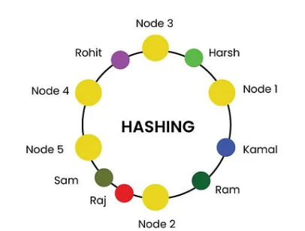
- Potential Issues:
- Hot Spots: Popular songs or artists might still cause “hot spots” where a few servers receive a disproportionate amount of traffic, even with good hash distribution. Virtual nodes can help mitigate this but add complexity. Whenever we add virtual node we need to add more space to add the virtual nodes and this is the tradeoff.
- Uneven Load Distribution on Node Changes: While consistent hashing minimizes key remapping, the load on the newly added server or the servers adjacent to a removed one can increase significantly and unevenly until data is fully rebalanced or caches are warmed.
- Data Replication and Availability: Consistent hashing itself doesn’t handle data replication. If a server fails, the songs it hosted become unavailable unless a robust replication strategy is in place. Managing replicas and ensuring data consistency across them adds complexity.
- Stateful Connections: Music streaming can involve stateful connections (e.g., user’s playback position, active stream). If a server handling a user’s stream fails, simply re-hashing to a new server might not be seamless without mechanisms to transfer or reconstruct that state.
- Geographical Latency: Basic consistent hashing doesn’t inherently consider user proximity to servers. Users might be directed to geographically distant servers, leading to higher latency. Geo-aware hashing strategies are needed but increase complexity.
- Churn Impact: Frequent server additions or removals (high churn) can still lead to significant data movement and temporary service degradation, even if less disruptive than traditional hashing.
- Complexity of Implementation: A robust consistent hashing scheme, especially with virtual nodes, replication, and geo-awareness, can be complex to implement and maintain correctly.
2. What are the pros and cons of using pre-loaded hints versus server-loaded hints in an application?
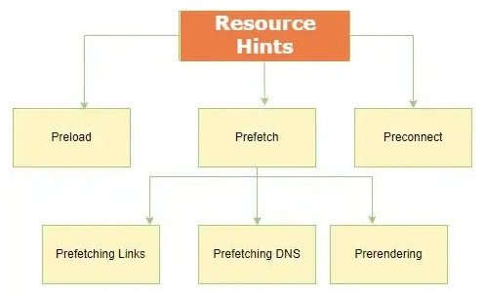
- Preload hints instruct the browser to request a resource as soon as possible, while server-loaded hints, such as Early Hints, are sent by the server to the browser before the full response is available, allowing the browser to start pre-fetching and preparing for the page. Preload hints are a command to the browser, while Early Hints are more of a suggestion.

3. How would you process a file that is larger than the available RAM on a single system?
- Processing a file larger than available RAM requires reading and processing it in smaller, manageable chunks.
- Streaming/Iterative Processing:
- Read the file piece by piece (e.g., line by line, or a fixed buffer size).
- Process each chunk immediately.
- Discard the chunk from memory (or write processed results to an output file) before reading the next one.
- This is suitable for operations that can be performed independently on parts of the file (e.g., counting occurrences, filtering lines, simple transformations).
- External Sort (for sorting operations):
- If the entire file needs to be sorted, an external merge sort is often used.
- Read chunks of the file that fit into RAM, sort them internally, and write these sorted chunks back to temporary files.
- Once all chunks are sorted, perform a k-way merge on the temporary sorted files to produce the final sorted output file.
- Specialized Libraries/Tools:
- Many programming languages and ecosystems have libraries designed for handling large datasets (e.g., pandas in Python has options for chunked reading, Dask for out-of-core computation).
- Command-line tools like awk, sed, grep, sort (with appropriate flags like -T for temporary directory) are often highly optimized for stream processing large files
- Database Systems:
- If the data is structured, loading it into a database (SQL or NoSQL) can be a good solution. Databases are designed to manage and query data much larger than RAM, using indexing and efficient disk I/O.
4. When expanding a production-ready application to multiple countries, what backend changes and considerations must be taken into account?
- Multiple countries mean different geolocations, so you’ll need additional servers in those regions for high availability — such as leveraging availability zones and regions.
- Key backend considerations and changes when expanding an application to multiple countries include:

- Internationalization & Localization:
- Support multiple languages and character sets.
- Localize timestamps, currency formats, and cultural norms.
- Manage translations and country-specific content.
- Regional Compliance & Data Privacy:
- Adhere to local regulations (e.g., GDPR in Europe).
- Determine data residency and storage locations.
- Handle data transfer requirements between jurisdictions.
- Payments & Currency Handling:
- Accept local payment methods and currencies.
- Ensure secure and compliant payment processing.
- Manage exchange rates and refunds in multiple currencies.
- Infrastructure & Performance:
- Use geographically distributed servers or CDNs.
- Optimize latency for cross-border traffic.
- Implement load balancing, caching, and failover strategies.
- Time Zones & Scheduling:
- Correctly store and display dates/times in local time zones.
- Ensure scheduled tasks work properly across time boundaries.
- Monitoring & Logging:
- Aggregate logs from distributed locations.
- Provide localized alerting and support.
- Scalability & Future Growth:
- Plan for increased traffic and user load in new regions.
- Keep infrastructure flexible for further expansion.

